CBOPTEST Reference Test Case Peer Review Document

This document serves a peer review template for a reference test case emulation model.

I. General Information 1
II. General Comments 2
III. Model Checks 3
IV. Test Case Checks 6
Appendix A: Documentation Template 8
Appendix B: KPI JSON 10
Appendix C: Specifications for Data CSV Files 11

Section I is to be completed by the Model Developer. The remaining sections are to be completed by the designated Model Reviewer, and returned to the Model Developer so that they may make the appropriate edits. This process should be repeated until all concerns of the reviewer are addressed. Each review should be documented using a separate version of this document, specified by the Review # in Section 1 below.

I. General Information

Test Case Name | Multizone Office Complex Air
Current Location (e.g. link to repository or direct file transfer) | Test Case Directory:  https://github.com/ibpsa/project1-boptest/issues/218  Modelica Model Package:  https://github.com/terrancelu92/project1-boptest/tree/issue406_largeoffice_spawn_squash/testcases/multizone_office_complex_air/models/MultizoneOfficeComplexAir  Model Path:  MultizoneOfficeComplexAir.TestCases.TestCase  Buildings Library Version:  See https://github.com/terrancelu92/project1-boptest/blob/issue406_largeoffice_spawn_squash/testcases/multizone_office_complex_air/models/library_versions.json
Model Developer  (Name, Institution, Email) | Xing Lu, PNNL, xing.lu@pnnl.gov
Model Reviewer  (Name, Institution, Email) | Kun Zhang, École de technologie supérieure, Canada, kun.zhang@etsmtl.ca
Review # | 1

II. General Comments
List each comment in separate row with number. Additional rows may be added as needed. They should be supported by the responses in Sections III and IV.

# |  | Comment
1 | √ | Documentation:  - The documentation for HVAC and control systems is good, especially the diagrams. However, the documentation for building envelope, internal gains, occupancy schedules etc. (MultizoneOfficeComplexAir.BaseClasses.LoadSide.LoadWrapper) is minuscule. It is suggested to add some brief descriptions for the building model to be more user-friendly. Please see the Section IV Documentation to include necessary information.  Response: The documentation for the building envelope, internal gains, and occupancy schedules is provided in the index.html file. Accordingly, we have also included this information in the LoadWrapper documentation for consistency and completeness.  - It is suggested to review the comments for inputs and outputs and revise some of the comments accordingly, at least for the first several layers of the model. This will facilitate the comprehension of the test case. For example, the output occ in the model MultizoneOfficeComplexAir.BaseClasses.LoadSide.LoadWrapper should be related to occupants. For temperature outputs in the same model, it is better to specify if they are temperatures of zones, or outdoor etc. since there are so many temperatures in the model.  Response: More detailed comments of the inputs and outputs are added to the higher level of the system models.  - In the documentation of MultizoneOfficeComplexAir.BaseClasses.HVACSide.HVAC, the arrow of bypass pipe in the chilled water loop is indicated two directions. Can the water flow in both directions?  Response: The bypass in the primary-secondary chilled water systems is permitted to operate in both directions, although under normal operating conditions, it should flow in only one direction. However, in rare situations or during transitional periods—such as when there's a flow deficit due to the low delta T syndrome—the flow may reverse.
2 | √ | The AHU system does not have a heating coil for cold climate like Chicago seems a bit odd to me. Not sure if this HVAC system design and specifications are from the original EnergyPlus model.  Response: It represents an older building that does not include a preheating coil at the AHU level. All heating is provided solely through the reheat coils.
3 | √ | Supply air flow on Floor 3: The fan is off on this weekend day but there is supply air flow in the AHU, see figure below.  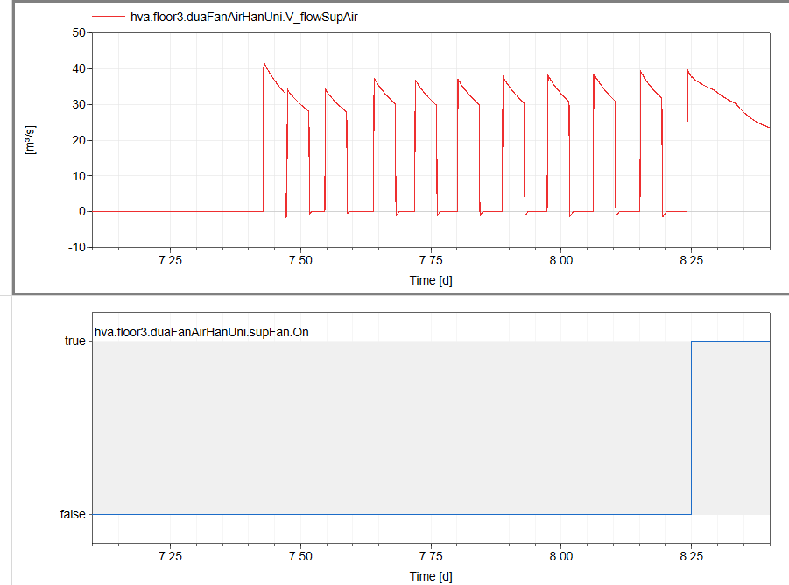  Response:  The fan is activated by the night cycle control signal, as showed in the third subplot below. During unoccupied periods, the night cycle is triggered when the zone temperature falls below the unoccupied heating setpoint (15.6°C). In such cases, the fan operates to prevent the zone from becoming too cold.  To improve clarity, we have separated the fan ON signals in the figure below: one representing the occupied period (where the fan remains continuously on), and the other representing the unoccupied period (where fan operation is conditional based on night cycle activation).  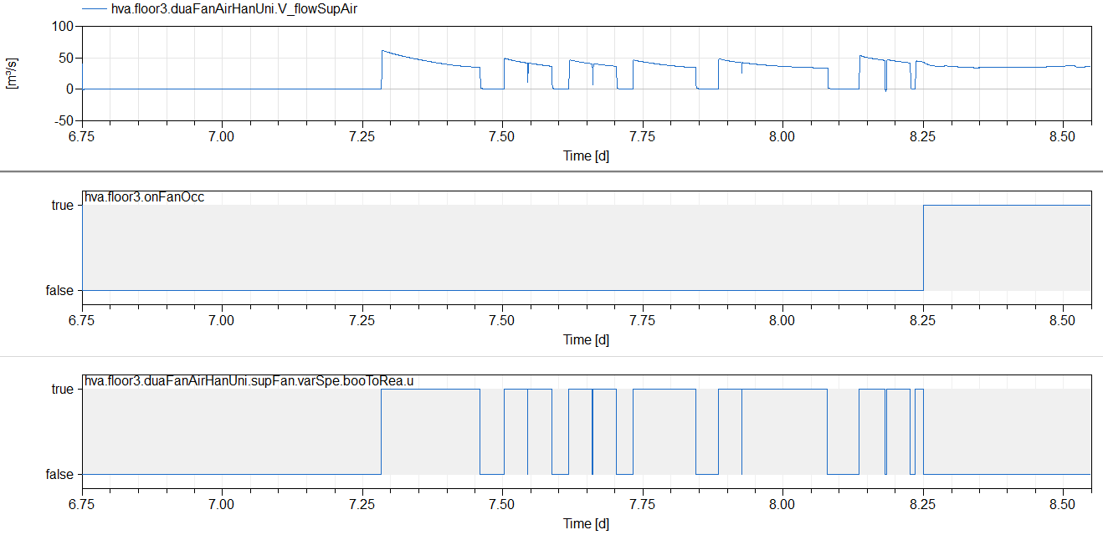  Occupied time fan signal  Night cycle fan signal
4 |  | Simulation failed at around 361 days, see the error message below (I used the same solver, tolerance and set a timestep of 30 minutes):  Warning: Failed to solve nonlinear system using Newton solver.  Time: 31216680  Tag: simulation.nonlinear[11]  Previous problem occured when evaluating crossing function, reducing step-size  cvode: CVODE cvRcheck3 At t = 3.12167e+07, the rootfinding routine failed in an unrecoverable manner.  Cannot recover from failed crossing function evaluation at time 3.12166e+07  CVode simulation failed  Integration terminated unsuccesfully at T = 3.12166e+07  CPU-time for integration : 23570.5 seconds  CPU-time for initialization : 9.69 seconds  Number of result points : 1074051  Number of grid points : 17343  Number of accepted steps : 7845322  Number of rejected steps : 393081  Number of f-evaluations (dynamics) : 13151029  Number of non-linear iteration : 10999201  Number of non-linear convergence failures : 16851  Number of Jacobian-evaluations : 663850  Number of crossing function evaluations : 7940836  Number of model time events : 522974  Number of state events : 14051  Number of step events : 0  Maximum integration order : 5  ERROR: The simulation of MultizoneOfficeComplexAir.TestCases.TestCase FAILED  31216620.000 TestCase.loaEnePlu.building: Warning from EnergyPlus: ** Warning ** Temperature out of range [-100. to 200.] (PsyPsatFnTemp)  31216620.000 TestCase.loaEnePlu.building: Warning from EnergyPlus: ** Warning ** WetBulb not converged after max iterations(PsyTwbFnTdbWPb)  Response: Several warnings were related to the non-linear equations in the hot water hydronics loop, which appeared to be the root cause of the simulation failure. To address this, we simplified the pressure drop modeling for the VAV terminal reheat hot water loops by setting the nominal pressure to zero. This adjustment eliminated all associated warnings, allowing the annual simulation to complete successfully without interruptions.  [Dymola 2021 Command]  simulateModel("MultizoneOfficeComplexAir.TestCases.TestCase", stopTime=31536000, outputInterval=600, method="Cvode", tolerance=1e-06, resultFile="TestCase");  [Log]  Integration terminated successfully at T = 3.1536e+07  CPU-time for integration : 35238.9 seconds  CPU-time for initialization : 17.913 seconds  Number of result points : 1158135  Number of grid points : 52562  Number of accepted steps : 7175105  Number of rejected steps : 284332  Number of f-evaluations (dynamics) : 12039639  Number of non-linear iteration : 9817447  Number of non-linear convergence failures : 20707  Number of Jacobian-evaluations : 678099  Number of crossing function evaluations : 7390192  Number of model time events : 528624  Number of state events : 24163  Number of step events : 0
5 | √ | Negative values of power are observed for the hot water pump during some periods (see an example below)  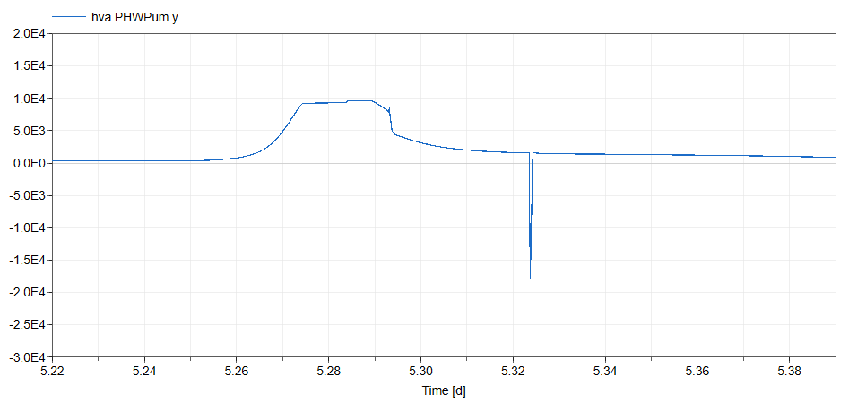  Response: Transient reverse water flow may occur through the parallel pumps during staging under certain conditions. To mitigate this, we have imposed a non-negative constraint on the hot water pump power output. The resulting simulation outputs are shown below  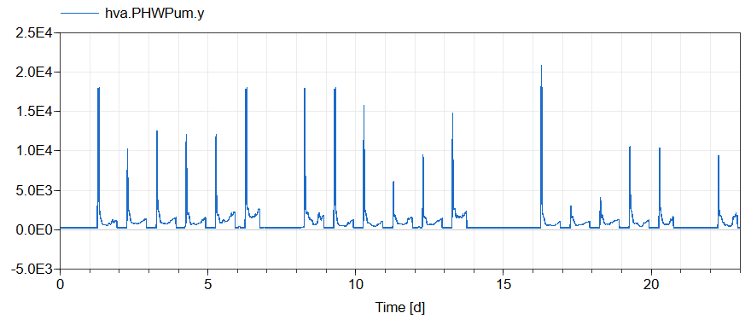
6 | √ | Infiltration mode: In the documentation for LoadWrapper, it writes: “The inputs are the zone air temperatures from Modelica that is responsible for the airflow calculation (e.g., building infiltration) and HVAC system and controls.” I do not see an infiltration model on the Modelica side. Please double check.  Response: Air infiltration features have been incorporated into the exterior zones on all three floors. The specified infiltration rate (m_flow_infAir) is based on an air leakage rate of 1 cfm/ft² of exterior surface area, measured at a constant building pressure differential of 75 Pa. This value is then converted to a wind-driven infiltration rate at a reference wind speed of 4.47 m/s, following the methodology outlined in ASHRAE Standard 90.1-2022, Section G3.2.1.7.  During occupied hours, the infiltration schedule uses a fraction of 0.25 to approximate the reduced infiltration rate resulting from mechanical ventilation being active. This assumption aligns with the modeling rules in Appendix C of ASHRAE Standard 90.1-2022. Additionally, the infiltration rate is dynamically adjusted to account for variations in wind speed.
7 | √ | Interzone airflow: If this aspect is not accounted in Modelica, please specify in the documentation  Response: No interzone airflow is modeled.
8 | √ | I could not find the definition of the alpha parameter in the VAV air mass flow rate.  Response: We have added the definition of the alpha parameter in the system, which serves as a sizing factor. In this model, it is set to 1.25.
9 | √ | I did not find any CO2 measurements.  Response: We have integrated CO₂ features into the building’s mixed air volume and fresh air source models. Additionally, CO₂ sensors have been added to all 15 zones and the 3 AHUs, with corresponding measurement outputs connected to the Read blocks in accordance with the BOPTEST template. For example, the simulation results showing CO₂ measurements across all 15 thermal zones are presented below:  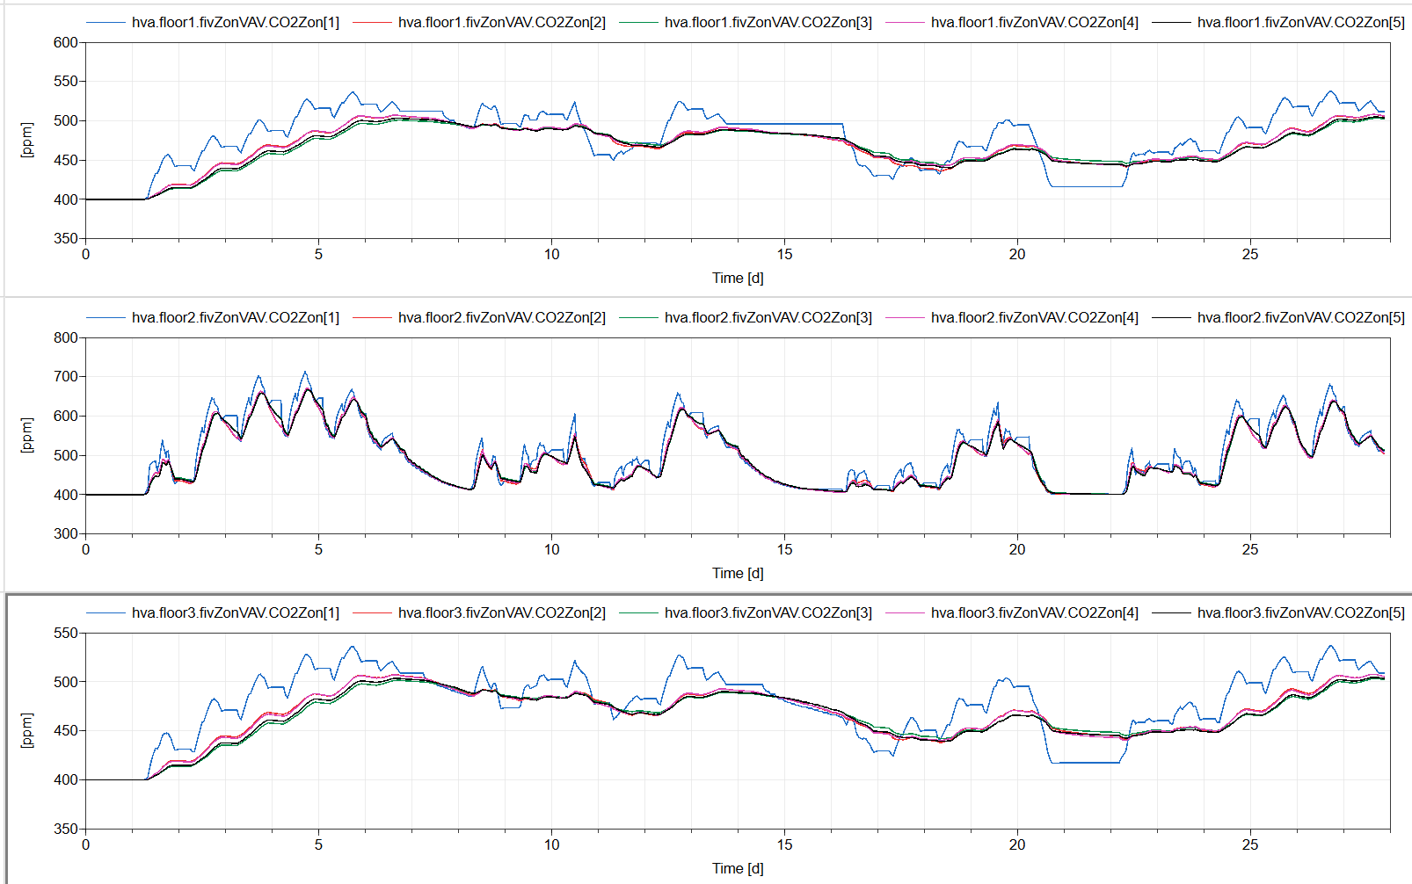
10 | √ | HTML: could be improved using different types of headers.  experiment( StartTime=17280000…) could be removed for models that do not simulate such as BaseClasses.HVACSide.HVAC.  Response: Modified.
11 | √ | Optional: adding a frame to some icons such as mixing box, cooling coil and supply fan (MultizoneOfficeComplexAir.BaseClasses.HVACSide.BaseClasses.Component.AirSide.AirHandlingUnit.DuaFanAirHanUnit) could enhance the readability of the model.  Response: Modified.
12 | √ | Optional: I do not see the need to create a model named WithoutMotor (MultizoneOfficeComplexAir.BaseClasses.HVACSide.BaseClasses.Component.FlowMover.BaseClasses.WithoutMotor)  Response: Agreed.

III. Model Checks

Criteria | Reviewer Response
Reference Case Representation
Does the model represent overall intent of reference case?  Are the relevant thermal systems, heat loads, and control signals accounted for? | Yes
Climate
Complete weather data file, similar to TMY? | Yes
Sufficiently long period, e.g. one year? | Yes
Internal Gains
Occupancy schedule? | Internal gains are from EnergyPlus
Occupancy gain values reasonable for building type? | NA
Lighting schedule/control? | NA
Lighting gain values reasonable for building type? | NA
Equipment schedule? | NA
Equipment gain values reasonable for building type? | NA
Envelope Modeling
Are IDEAS, Buildings, or AixLib component models used for building envelope and window modeling? | No, Envelope model is from EnergyPlus.
If not IDEAS, Buildings, or AixLib component models, are dynamic wall heat transfer models used? | Yes
If not IDEAS, Buildings, or AixLib component models, are complex fenestration models used? | Yes
If not IDEAS, Buildings, or AixLib component models, is latitude and longitude consistent with intended region or weather file? | Yes
If not IDEAS, Buildings, or AixLib component models, are convection models for inside and outside nonlinear? | Yes
If not IDEAS, Buildings, or AixLib component models, are the inside and outside radiation models appropriate? | Yes
Are window surface areas reasonable? | Yes
Are insulation levels reasonable? | Yes
Are all surfaces accounted for? (e.g. the roof is not forgotten) | Yes
Which of the following is used for modeling air infiltration?  None  Constant  Pressure-driven flow  Buoyancy-driven flow  Mixed pressure and buoyancy-driven flow | Not clear. See Comment #6  Response: Prescribed airflow rate based on the ASHRAE 90.1-2022 Appendix G rules.
Inter-zone airflow and common wall heat transfer properly accounted for? | Not accounted in Modelica.
HVAC Modeling
Are moisture and condensation effects properly accounted for? | Yes
Are fluid components such as ducts, pipes, actuators, pumps, fans, and heat exchangers modeled with pressure-flow relationships? Are pressure drops reasonable? | Yes
Is the heat transfer performance of other equipment such as heat exchangers and plant equipment modeled reasonably? | Yes
Are equipment capacities reasonable? | Yes, could not find the definition of the alpha parameter in the VAV air mass flow.  Response: Alpha parameter is the sizing factor, which is 1.25.
Are equipment efficiencies such as COP, heating, hydraulic, and motor reasonable? | Yes
Is reasonable baseline control provided in the model? Can the model be simulated without an external controller? | Yes
External Control Input Signals
Are Modelica signal exchange blocks used? | Yes
Reasonable set of external control signals? | Yes
Units assigned?  In SignalExchange.Overwrite assign a unit to the input variable u. | Yes
Descriptions assigned?  In SignalExchange.Overwrite use the parameter description. | Yes
Min/max assigned?  In SignalExchange.Overwrite assign a min and max to the input variable u. | Yes
Measurement Output Signals
Are Modelica signal exchange blocks used? | Yes
Reasonable set of measurement output signals for HVAC and building operation? | Yes
Reasonable set of measurement output signals for weather? Is the SignalExchange.WeatherStation block used? | Yes
Is at least one, and more if necessary, of the following KPI labels used to account for equipment power/fuel consumptions for KPI calculation? Is power consumption from all relevant equipment tagged? {ElectricPower, DistrictHeatingPower, GasPower, BiomassPower, or SolarThermalPower}  In SignalExchange.Read, use the parameter KPIs. | Yes
Are all necessary zone temperatures tagged with one of the following KPI labels for KPI calculations and appropriate zone identifier(s) given?  {AirZoneTemperature or OperativeZoneTemperature}  In SignalExchange.Read, use the parameters KPIs and zone. | Yes
Are all zone CO2 measurements tagged with the following KPI label for KPI calculations and appropriate zone identifier(s) given?  {CO2Concentration}  In SignalExchange.Read, use the parameters KPIs and zone. | No, I did not find any CO2 measurements  Response: CO2 measurement is added.
Units assigned?  In SignalExchange.Read assign a unit to the output variable y. | Yes
Descriptions assigned?  In SignalExchange.Read use the parameter description. | Yes
Compilation and Simulation
Uses official library release versions (with Modelica “Uses” statement)? | Yes
Can be compiled into co-simulation FMU that can be simulated without use of commercial licensing? | Yes
What is the intended solver, tolerance, and timestep (if constant timestep solver)? Are these reasonable to simulate the model dynamics? | solver="Cvode", tolerance=1e-06. Timestep is not specified, instead number of intervals is specified as 1440. Calculated timestep is 30 minutes. Perhaps it is better to specify a shorter timestep?  Response: The annual simulation is conducted in Dymola 2021 by the following command:  simulateModel("MultizoneOfficeComplexAir.TestCases.TestCase", stopTime=31536000, outputInterval=600, method="Cvode", tolerance=1e-06, resultFile="TestCase");
Simulates for full year? | No, see Comment #4  Response: The simulation runs for full year non-stop.

IV. Test Case Checks

Criteria | Response
Documentation
Building Design and Use  (including architecture, constructions, occupancy schedules and comfort, internal loads and schedules, climate) | No
HVAC System Design  (including primary and secondary system designs, equipment specifications and performance maps, rule based and/or local loop controllers) | With some descriptions and diagrams for HVAC systems but no system design, equipment specifications etc.  Response: The system design is described in /doc/index.html
Additional System Design  (such as lighting, shading, onsite generation and storage) | No
Points List  (including control inputs signals with descriptions, units, min/max, and default values, and measurement output signals with descriptions and units) | No
Important Model Assumptions  (such as infiltration models, moist/dry air assumptions, well-mixed assumptions, CO2 generation from occupants and concentration in outside air) | No
Scenario Information  (including time periods, energy pricing, and emission factors) | No
HTML template followed (see Appendix A)? | Yes but could be improved using different types of headers.  experiment( StartTime=17280000…) could be removed for models that do not simulate such as BaseClasses.HVACSide.HVAC.  Response: Revised.
BOPTEST Data Requirements
If model DOES NOT make use of signal exchange Modelica blocks, is a KPI JSON provided for matching output signals to KPI keywords (see Appendix B)? | NA
Is a Days JSON provided for specifying scenario time periods (see Appendix B)? | NA
Data for weather provided as csv with correct header names (see Appendix C)?  Does the data of this type used within the model match the data provided in the csv? | Yes
Data for zone comfort setpoint temperature(s) for each zone provided as csv with correct header names (see Appendix C)? Does the data of this type used within the model match the data provided in the csv? | Yes
Data for occupancy (number of occupants) schedule for each zone provided as csv with correct header names (see Appendix C)?  Does the data of this type used within the model match the data provided in the csv? | Yes
Data for internal gains for each zone provided as csv with correct header names (see Appendix C)?  Does the data of this type used within the model match the data provided in the csv? | Yes
Data for GHG emission factors for each fuel source provided as csv with correct header names (see Appendix C)? | Yes
Data for energy pricing provided as csv with correct header names (see Appendix C)? | Yes

Appendix A: Documentation Template

<html>
General model description.
<h3>Building Design and Use</h3>
<h4>Architecture</h4>
<p>
…
</p>
<h4>Constructions</h4>
<p>
…
</p>
<h4>Occupancy schedules</h4>
<p>
…
</p>
<h4>Internal loads and schedules</h4>
<p>
…

</p>
<h4>Climate data</h4>
<p>
…
</p>
<h3>HVAC System Design</h3>
<h4>Primary and secondary system designs</h4>
<p>
…
</p>
<h4>Equipment specifications and performance maps</h4>
<p>
…
</p>
<h4>Rule-based or local-loop controllers (if included)</h4>
<p>
…
</p>
<h3>Model IO's</h3>
<h4>Inputs</h4>
The model inputs are:
<ul>
<li>
<code>Input1</code> [UNIT1]: Description
</li>
</ul>
<h4>Outputs</h4>
The model outputs are:
<ul>
<li>
<code>Output1</code> [UNIT1]: Description
</li>
<li>
<code>Output2</code> [UNIT2]: Description
</li>
</ul>
<h3>Additional System Design</h3>
<h4>Lighting</h4>
<p>
…
</p>
<h4>Shading</h4>
<p>
…
</p>
<h4>Onsite Generation and Storage</h4>
<p>
…
</p>
<h3>Model Implementation Details</h3>
<h4>Moist vs. dry air</h4>
<p>
…
</p>
<h4>Pressure-flow models</h4>
<p>
…
</p>
<h4>Infiltration models</h4>
<p>
…
</p>
<h4>CO2 models</h4>
<p>
…
</p>
<h3>Scenario Information</h3>
<h4>Time Periods</h4>
<p>
…
</p>

<h4>Energy Pricing</h4>
<p>
…
</p>
<h4>Emission Factors</h4>
<p>
…
</p>
</html>

Appendix B: JSONs

KPI JSON

{<kpi_ID> : // Unique identifier for KPI
[<output_ID>] // List of FMU outputs to be included in calculation
}

Saved as “kpis.json”
For kpi_IDs requiring zone designations, the zone designation can be appended to the end of the kpi_ID as <kpi_ID>[z], where z is the zone designation. These are AirZoneTemperature[z], OperativeZoneTemperature[z], and CO2Concentration[z].

Days JSON

{<time_period_ID> : // Unique identifier for specifying time period
<day #> // Integer value indicating day number to use for specifying time period
}

Saved as “days.json”

Appendix C: Specifications for Data CSV Files

This information is taken from the BOPTEST Development Requirements and Guide Section IV. D.

The CSV data files should accomplish the following requirements:

- The files can have any name.
- The files should have a “time” column indicating the time since the beginning of the year in seconds.
- The files should have column names using the key-words specified by the conventions below. Columns that do not apply to the test case may be omitted (e.g. EmissionsGasPower if the test case does not use gas power).
- The files can have optional header rows for holding information about the data contained in the csv file. These header rows can be indicated by starting the row with the character "#".
Data for the CSV files may optionally be generated using the functions that are available in the module data/data_generator.py located in the software repository at https://github.com/ibpsa/project1-boptest. Default parameters for these functions may be used, or modified based on the test case. If default parameters are used, care should be taken to make sure the resulting data matches that which may be used in the test case model.

CATEGORY: weather
NAME | UNIT | DESCRIPTION
HDifHor | W/m2 | Horizontal diffuse solar radiation.
HDifNor | W/m2 | Direct normal radiation.
HGloHor | W/m2 | Horizontal global radiation.
HHorIR | W/m2 | Horizontal infrared irradiation.
TBlaSky | K | Output temperature.
TDewPoi | K | Dew point temperature.
TDryBul | K | Dry bulb temperature at ground level.
TWetBul | K | Wet bulb temperature.
celHei | m | Ceiling height.
cloTim | s | One-based day number in seconds.
lat | rad | Latitude of the location.
lon | rad | Longitude of the location.
nOpa | 1 | Opaque sky cover [0, 1].
nTot | 1 | Total sky Cover [0, 1].
pAtm | Pa | Atmospheric pressure.
relHum | 1 | Relative Humidity
solAlt | rad | Altitude angel.
solDec | rad | Declination angle.
solHouAng | rad | Solar hour angle.
solTim | s | Solar time.
solZen | rad | Zenith angle.
winDir | rad | Wind direction.
winSpe | m/s | Wind speed

CATEGORY: prices
NAME | UNIT | DESCRIPTION
PriceElectricPowerConstant | ($/€)/kWh | Completely constant electricity price
PriceElectricPowerDynamic | ($/€)/kWh | Electricity price for a day/night tariff
PriceElectricPowerHighlyDynamic | ($/€)/kWh | Spot electricity price
PriceGasPower | ($/€)/kWh | Price to produce 1 kWh thermal from gas
PriceDistrictHeatingPower | ($/€)/kWh | Price of 1 kWh thermal from district heating
PriceBiomassPower | ($/€)/kWh | Price to produce 1 kWh thermal from biomass
PriceSolarThermalPower | ($/€)/kWh | Price to produce 1 kWh thermal from solar irradiation

CATEGORY: emissions
NAME | UNIT | DESCRIPTION
EmissionsElectricPower | kgCO2-eq/kWh | Kilograms of carbon dioxide equivalent to produce 1 kWh of electricity
EmissionsGasPower | kgCO2-eq/kWh | Kilograms of carbon dioxide equivalent to produce 1 kWh thermal from gas
EmissionsDistrictHeatingPower | kgCO2-eq/kWh | Kilograms of carbon dioxide equivalent to produce 1 kWh thermal from district heating
EmissionsBiomassPower | kgCO2-eq/kWh | Kilograms of carbon dioxide equivalent to produce 1 kWh thermal from biomass
EmissionsSolarThermalPower | kgCO2-eq/kWh | Kilograms of carbon dioxide equivalent to produce 1 kWh thermal from solar irradiation

CATEGORY: occupancy
NAME | UNIT | DESCRIPTION
Occupancy[z] | Number of occupants | Number of occupants at zone ‘z’

CATEGORY: internalGains
NAME | UNIT | DESCRIPTION
InternalGainsRad[z] | W | Radiative internal gains at zone ‘z’
InternalGainsCon[z] | W | Convective internal gains at zone ‘z’
InternalGainsLat[z] | W | Latent internal gains at zone ‘z’

CATEGORY: setpoints
NAME | UNIT | DESCRIPTION
LowerSetp[z] | K | Lower temperature set point of the comfort range at zone ‘z’
UpperSetp[z] | K | Upper temperature set point of the comfort range at zone ‘z’
UpperCO2[z] | ppm | Upper CO2 concentration limit for zone ‘z’

